Flight Data Analysis
by
Anupam Sahay, Nitesh Kamboj, Zeeshan I Khan, Sohang Chakraborty and Krithy Nanaiah Atrangada
Department of Information Systems, California State University
Los Angeles
e-mail: asahay@calstatela.edu, nkamboj@calstatela.edu, zkhan7@calstaela.edu, schakra2@calstatela.edu, katrang@calstatela.edu

Abstract: The prediction of flight delays is heavily investigated in the last few decades. However, there is a relatively low level of study on Random flight point delays in these important problems. Managing an airport is very complex. Decisions are often based on common sense and influence several variables, such as flight delay. This paper considers the problem of predicting flight departure delay at few of the busiest Airports.

Keywords: Hadoop, Apache PIG, Tableau, Data Analysis, Data Visualization

- Introduction

Flight delays have been attributed to several causes such as weather conditions, airport congestion, airspace congestion, use of smaller aircraft by airlines, etc.
In this paper, we are going to examine a dataset provided by the United States Department of Transportation, Bureau of Transportation Statistics, containing data from the years 1987-2008. We are going to provide unique insights related to the dataset in this paper, some of them being, commercial carriers with the most number of delays, airports witnessing the maximum delays, factors which played a crucial role in the delaying of the commercial flights, month which witnessed the highest number of delays, number busy routes between two airports. We also discuss more generally the future development of the dataset.

- Hadoop, Apache Pig and Tableau

In recent years, flight delay has been one of the most significant reasons that lead to inconvenience and inefficiency of people daily lives or business trips. And due to the highly developed transportation system of airplanes, flight delay problem has become more and more serious. No events have characterized the past centuries more dramatically than the explosion of these big data in information era. Less important than ever is the data mining technology to analyze and predict future trends. In flight delay area, a more accurate model needs to be built to enable us to predict the delay possibility of a flight. It will alleviate the pressure of the whole flight chain and the whole aviation system.
Studies agree that there is a close relation between arrival delay and departure delay. Some of them treat flight delay prediction as a regression problem, predicting the delay by the minute, and others as a classification problem, predicting a time interval where the delay will fall.
The relationship between airport congestion and passenger delays at an airport is determined by many factors. Among these factors are scheduled and actual flight times, flight itineraries, airport capacity, and turnaround time between flights. From the existing recorded data, it is possible to present a general profile of both airport congestion and passenger delays, measured with respect to the published schedule, at major airports within the US. This paper illustrates the discrepancy between the two measurements. Airport congestion may be masked by flight schedules which account for routine arrival delays and/or with slack time provided for turnaround at an airport. It is possible for an airport to be heavily utilized, with little or unnoticeable at-gate delays (measured with respect to scheduled arrival time). On the other hand, at-gate delays can occur at under-utilized airports. Arrival and departure queuing delays are better indicators of airport congestion than passenger delays. Average flight at-gate delays are derived from performance data and compared with simulation results for 30 of the busiest airports in USA for a good weather day. The effects of variations in schedule flight time and slack time are studied parametrically in the simulation and calibrated to match the recorded baseline national airspace system (NAS) delay profiles. This paper illustrates a technique for estimating NAS-wide impact of propagated flight delays, based upon a method for calibration a system-level simulation against real world delays as well as delays derived from other simulations.

2.1 Apache PIG: Apache Pig is a high-level platform for creating programs that runs on Apache Hadoop. The language for this platform is called Pig Latin. Pig can execute its Hadoop jobs in MapReduce, Apache Tez, or Apache Spark. Pig Latin abstracts the programming from the Java MapReduce idiom into a notation which makes MapReduce programming high level, similar to SQL for relational database management systems. Pig Latin can be extended using user-defined functions (UDFs) which the user can write in Java, Python, JavaScript, Ruby or Groovy and then call directly from the language.
2.2 Clouldera: Cloudera Inc. is a United States based software company that provides Apache Hadoop based software, support and services, and training to business customers. Cloudera's open-source Apache Hadoop distribution, CDH (Cloudera Distribution Including Apache Hadoop), targets enterprise-class deployments of that technology. Cloudera says that more than 50% of its engineering output is donated upstream to the various Apache-licensed open source projects (Apache Hive, Apache Avro, Apache HBase, and so on) that combine to form the Hadoop platform. Cloudera is also a sponsor of the Apache Software Foundation.
2.3 Hadoop: Apache Hadoop is an open source software framework used for is an open-source software for distributed storage and processing of dataset of big data using the MapReduce programming model. It consists of computer clusters built from commodity hardware. All the modules in Hadoop are designed with a fundamental assumption that hardware failures are common occurrences and should be automatically handled by the framework. The core of Apache Hadoop consists of a storage part, known as Hadoop Distributed File System (HDFS), and a processing part which is a MapReduce programming model. Hadoop splits files into large blocks and distributes them across nodes in a cluster. It then transfers packaged code into nodes to process the data in parallel. This approach takes advantage of data locality, where nodes manipulate the data they have access to. This allows the dataset to be processed faster and more efficiently than it would be in a more conventional supercomputer architecture that relies on a parallel file system where computation and data are distributed via high-speed networking.

2.4 Tableau: Tableau software is a software which produces interactive data visualization products focused on business intelligence. It initially began in order to commercialize research which had been conducted at Stanford University's Department of Computer Science, it was founded in Mountain View, California. The product queries relational databases, OLAP cubes, cloud databases, and spreadsheets and then generates a number of graph types. Tableau has a mapping functionality, and is able to plot latitude and longitude coordinates. It has been criticized for being overly US-centric. They also offer custom geocoding, as well as five ways to access their products: Desktop (both professional and personal editions), Server, online (which scales to support thousands of users), Reader, and Public, with the last two free to use. Vizable, a consumer data visualization mobile app, was released in 2015.

- Insights

3.1 Insight-1: The first insight shows the Airline carrier which was the most popular in a given year. According to the query we have made, Delta flights in the month of October from the year 1987 to 2008 had an average popularity of 6.158. This can be seen in the following figure.
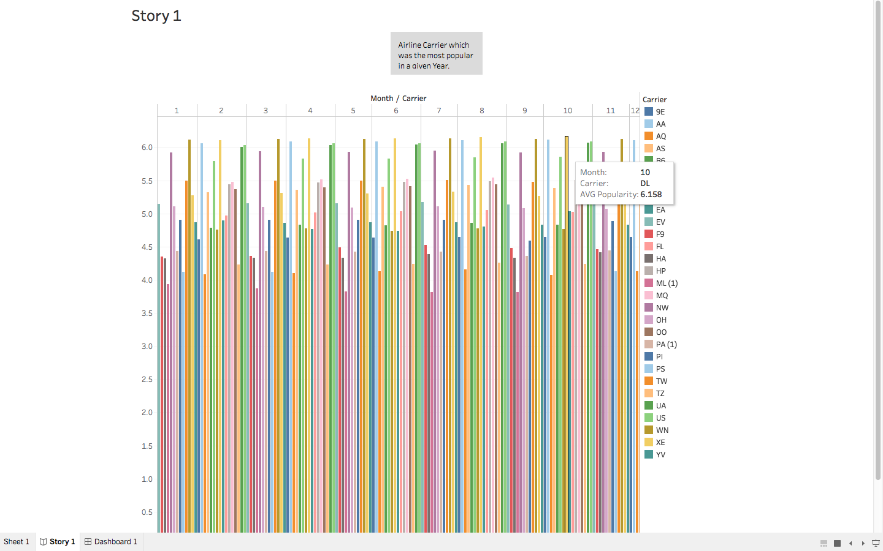
Figure 1: Airline Carrier which was the most popular in a given Year

3.2 Insight-2: The second insight is about the Outbound flights from the Top 20 airports in USA. And it covers a timespan from 1987 to 2008.
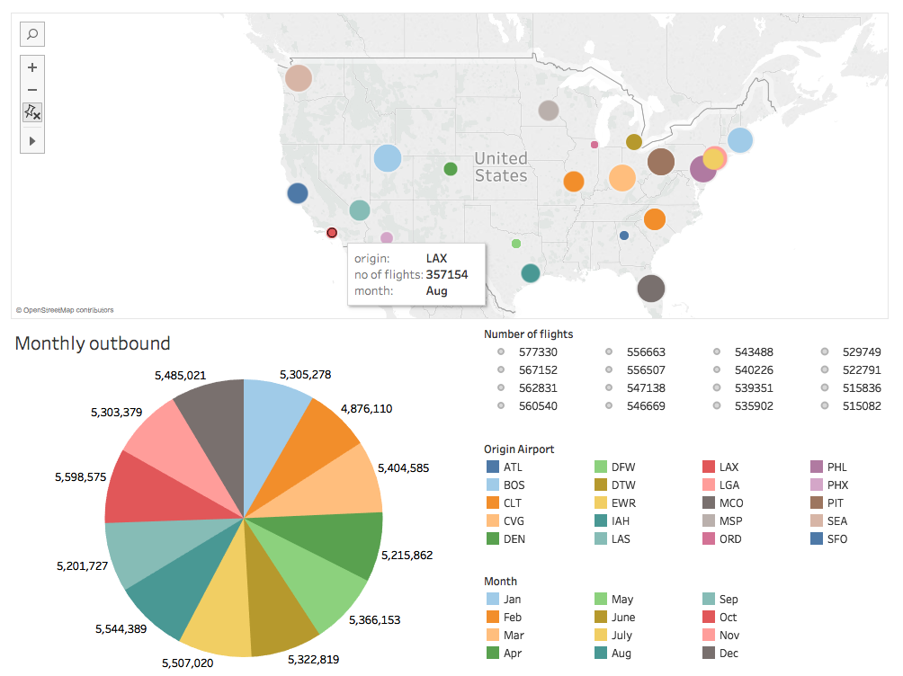
Figure 2: Outbound flights from Top 20 airports on departure basis

3.3 Insight-3: The third insight covers the total flights from the Top 20 airports on monthly traffic basis Inbound and Outbound which shows the timespan from the years 1987 to 2008.
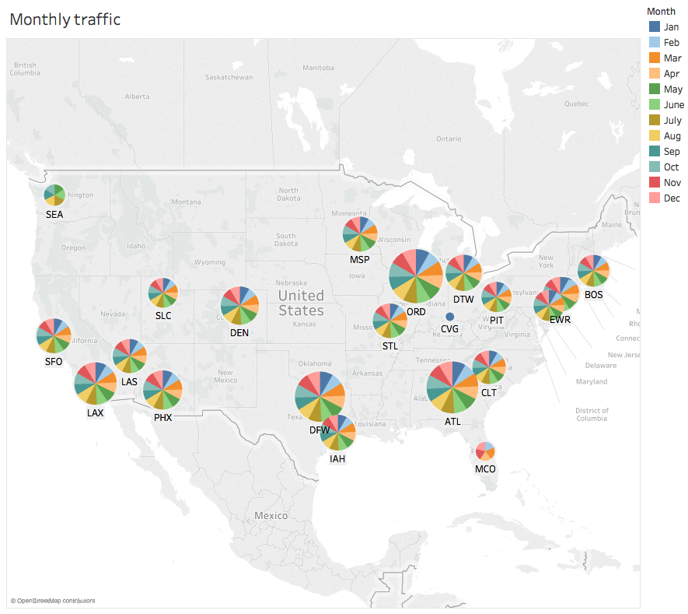
Figure 3: Total flights from Top 20 airports on monthly traffic basis
3.4 Insight-4: The fourth insight covers the Total flights originating from LAX to all the other airports in a timespan for the year 1987 to the year 2008.
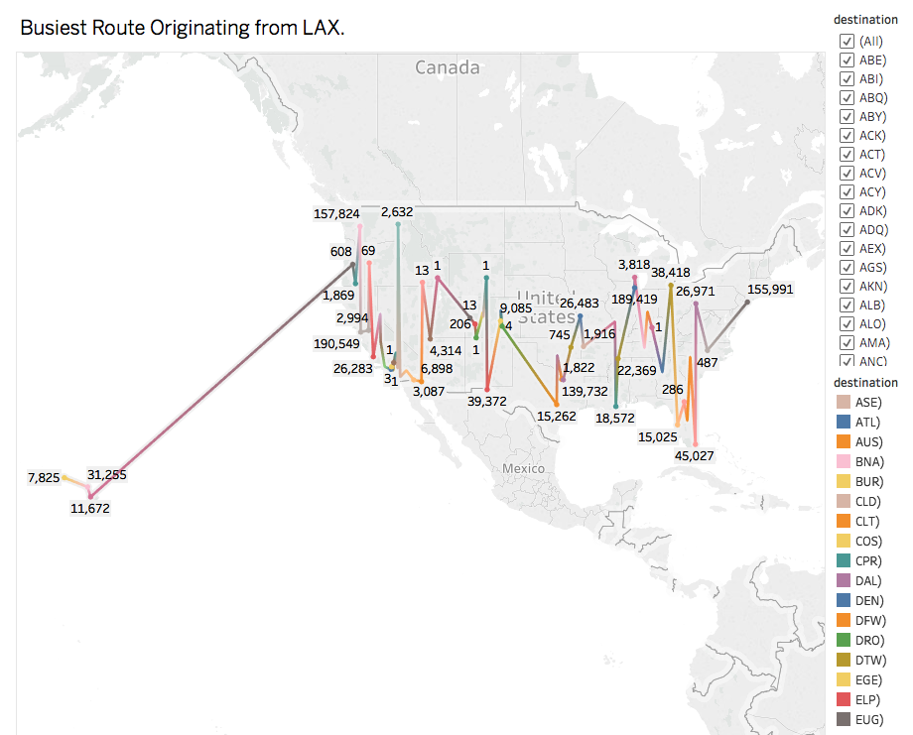
Figure 4 : Total flights originating from LAX to other airports
3.5 Insight-5: This insight covers the Carrier specific average delay where the total arrival and departure delay is more than or equal to fifteen minutes.
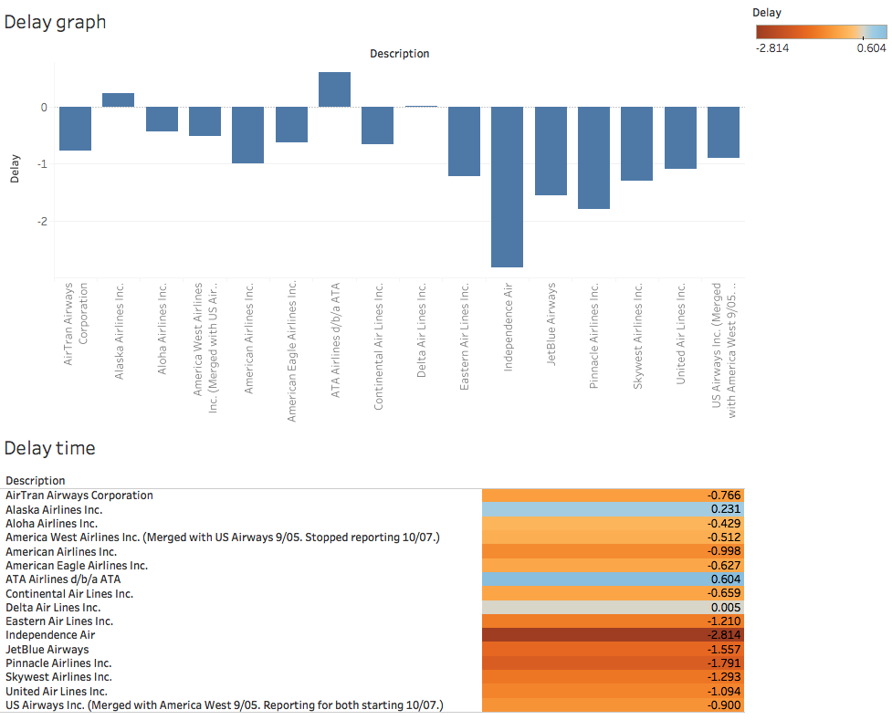
Figure 5: Carrier specific average delay
3.6 Insight-6: The sixth insight covers the Longest flight between two airports where we have taken the entire data for analysis which comprises of the analysis of the data from year 1987 to 2008.
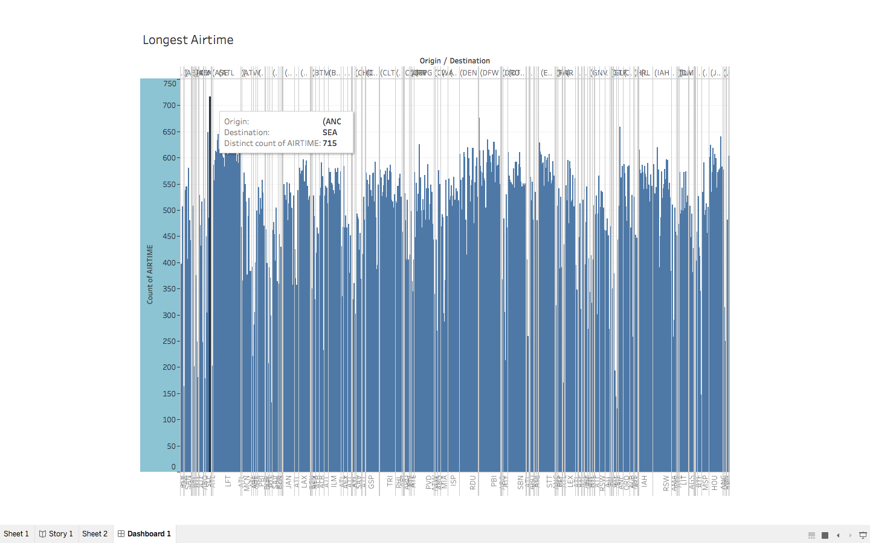
Figure 6.1 Longest flight between two airports

Conclusion

From the above experimental results, we can see that interesting sets of trends and patterns exists in large data sets which helps us to get a better understanding of the data.
Airline Carrier which was the most popular in a given Year, By looking at this insight the airline specific marketing companies can narrow their products/services to specific carriers. Outbound flights from Top 20 airports on departure basis, airport authority of USA can narrow their traffic management resources at specific airports. Total flights from Top 20 airports on monthly traffic basis, the marketing companies can divide their funds for marketing of product/services on monthly basis when as the insight give the info about monthly traffic. Total flights originating from LAX to other airports, local LAX authorities have the info about the flights to other airports and can rework on the terminal allocation of flights on the basis of outbound traffic to certain airports. Carrier specific average delay, this insight will help the carriers to look at the competitions and users will have more knowledge about the delay timings of the carriers. Longest flight between two airports, the marketing companies can choose to showcase their product/services advertisement multiple times on AV devices due to longevity of the flight.

References
[1] T.A. Jones, “Writing a good paper,” IEEE Trans. on General Writing, Vol. 1, no. 2, pp.1-10, May 2002.
[2] K. Hwang, Computer Arithmetic, John Wiley, 1997.
[3] Nillohit Bhattacharya and Jongwook Woo, "Airline Data Set Analysis using Big Data in Cloud Computing" in The 2017 Korea Society of Management Information Systems Spring Annual Conference (KMIS 2017), Chonnam University, Korea, June 6 - 9 2017

